Executive Summary

Zima Pizza
Tasty, fast food for you!

Krista Liguori, Sarina Katz, Yixin Sun, Xin Wen.
PI: Khanjan Mehta, Director, HESE Program
Website: http://youtu.be/QawlNhqtG-M
Humanitarian Engineering and Social Entrepreneurship (HESE) Program
The Pennsylvania State University
 | 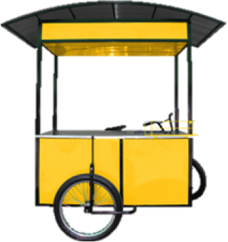
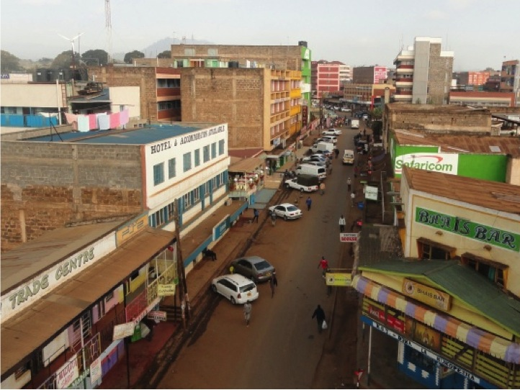 | 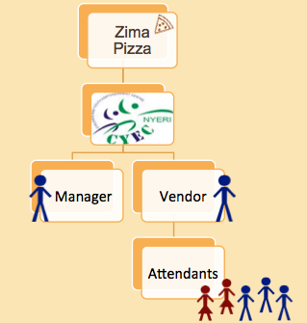
Problem / Market Opportunity
Zima Pizza, a branded food cart venture, addresses three problems experienced by Kenyans, but more specifically those living in the town of Nyeri: lack of accessibility to nutritious meals, the stigmatization of former street youth, and the high national unemployment rate.
Various sectors of the population lack accessibility to healthy meal options due to impoverishment caused by unemployment and stigmatization, particularly of former street dwelling youth, which acts as a barrier to entry in the workforce. Currently, these sectors sustain themselves on core crops of corn and beans; lacking in nutrients we find these poor diet habits to be directly related to malnutrition and the incidence rates of non-communicable diseases (NCDs). The local population has rates of malnutrition up to 37% as well as 386,000 children under 5 malnourished, and Nyeri has recorded the highest rate of diabetes in all of Africa, 6.8%. Our food cart will not only offer healthy meals, but by providing employment we can raise the standard of living to allow these people to afford healthier meals.
The high unemployment rate of Nyeri residents was estimated by the 2009 Kenyan census at 42.1% of all urban males living in this region. Our food cart business will hire motivated individuals at competitive salaries as managers and food cart vendors.
Finally, we address the stigmatization of former street dwelling youth (FSDY). In Kenya, there is estimated to be 250,000 street dwelling youth and in Nyeri alone, roughly 95% of children are found to be extremely poor; our food carts will employ these former street youth as cart and kitchen attendants. The skills gained in this job will allow successful employees to one day run their own vending cart or begin their own business as an entrepreneur.
Our Solution
Zima Pizza is a new business plan designed for alleviating the major problems of unemployment, the stigmatization of former street youth, and the prevalence of non-communicable diseases resulting from poor nutrition in the Nyeri region of Kenya. Through our mobile food cart business, we will not only provide healthy meals to an undernourished population but incorporate health education through community health workers as well. Our business employs former street dwelling youth from the Community Youth Empowerment Center in addition to local entrepreneurs to lower unemployment rates and provide increased income for hard-working individuals.
Using local and staple foods to create an innovative recipe, our Kenyan pizza, we will provide consumers with a valuable product that is high in nutritional content. Our mobile business will introduce healthy recipes to locals and spread awareness about the impacts nutrition can have on health. As a region with high incidences of non-communicable diseases such as diabetes, we will create a health movement by empowering and inspiring people to eat healthfully.
Product validation for our business is seen through the presence of food carts currently operating in the Nairobi area, the strong viability of food cart businesses throughout the world, and the strength of the pizza industry. Pizza is rare in Nyeri, available only at a handful of sit-down restaurants without serious competition. Our business is innovative because we are creating an aspirational brand through quality control and the creation of an efficient network of vendors with local farmers. Local relationships with farmers enables bulk pricing for affordable food materials while supporting the local community and economy. Seeing our brand logo ensures the consumer they are getting a quality, nutritious meal from a sanitary provider. Food is one commodity that is always in demand and guaranteed to sustain a strong market.
Zima Pizza includes two core innovations: our recipe and the branded network. Current meals lack veggies and rely heavily on cereals and starches, which contributes to the high rate of non-communicable diseases. To address this problem, a varied and vegetable filled pizza option utilizing local ingredients (kale, beans, cabbage, tomato, red onion, bell peppers, flour etc.) will be introduced to the local market. By utilizing local ingredients we can drastically reduce the cost, and also increase the initial acceptance of our product. Through establishing a branded network, market research can be done to improve the performance of our business to locate prime cart locations and provide the optimal experience for consumers. A branded network can also be integrated into the marketing strategy, which provides incentives for our stakeholders to follow the established rules and prevents imitators from eliminating us from the market.
The only competition for serving pizza in Nyeri, Kenya is the White Rhino, a sit-down restaurant with high prices that requires a long period of time for the meal. Other competitors are the current food cart hawkers and the market square stands. Zima Pizza stands out from sit-down restaurants because we provide an extremely accessible and affordable product to people who may not have the time or money to spend hours on a meal. We excel past the current hawkers and stands because we follow strict health standards, sanitation regulations, and train our employees to operate under a strict set of rules. The brand logo we display is evidence of our network and commitment we have to ensuring our customers a healthy, safe meal and a desirable customer experience.
Business Model
There are 3 primary customer segments for Zima Pizza. The first is travelers. This segment will frequent the cart throughout the day and be open to trying our Kenyan Pizza. The second segment is professionals, who tend to eat an earlier lunch, at which time they will visit our cart for a quick, healthy, delicious meal. Jua kali workers are our third segment; Jua kalis are likely to eat from our cart during a later lunch time.
Our first customers will likely be travelers. Travelers are in a mindset to try new things, may have experience with enjoying pizza elsewhere, and have disposable income. This set of customers will bet her first to try, and enjoy, our pizza, setting into motion our business. Because our food carts will spend the majority of time set up by Matatu stations, we will have direct access to these people as they travel into and out of the town.
Zima Pizza is our over-arching company, a subset of Penn State's Humanitarian Engineering and Social Entrepreneurship program. Zima Pizza will connect and develop partnerships with other key players, and be the main point of hiring both manager and vendor. The Children and Youth Empowerment Center (CYEC) is Zima Pizza's connection to the community in Nyeri, Kenya. The CYEC will serve as our preparation kitchen and storage facility. Our vendor hires maturing former street youth from the CYEC to man the kitchen and cart. Our manager will be a local businessperson who visits the carts three times daily to ensure quality control and standardization. They are responsible for cash flow and money deposits. A local businessperson will be hired as the vendor, who will man the cart on a daily business and prepare the food directly for consumers. Two cart attendants will travel around Nyeri for promotion of the cart. One will remain at the cart for maintenance work, dishes, etc. Two kitchen attendants will prepare the food at the CYEC and stock the cart on a daily business for travel to Nyeri. An unpaid member of our network who will increase business by using samples and recipes to promote healthy eating habits and the alleviation of NCD causes will be the Mashavu community health workers (CHW).
Zima Pizza’s daily operations began with the kitchen attendants preparing food and stocking the carts daily. The food carts will be stored at the CYEC, approximately 2 miles from the CYEC. Each morning, the vendor travels, with cart, to Nyeri Town. The vendor remains at the cart to prepare food throughout the day, addressing each of our customer segments as they come. Cart attendants are based in Nyeri for the day; one will travel the town doing promotion, and 2 stay behind for cart maintenance. The manager visits the cart three times daily to ensure quality control and standardization. Our manager collects the necessary money, and deposits it into the appropriate bank accounts. Mashavu CHWs will visit our carts to pick up samples, share with their customers, and ultimately help promote not only our business but our social mission.
Our revenue structure ensures that all partners rely on each other for their daily income, ensuring that our network is secure, thereby reducing the probability of money corruption and bribery. Zima Pizza’s initial investment will be repaid in the first fourteen months of operation. This revenue is generated through a licensing fee paid by the vendor. In addition, a proportion of the vendor’s commission is ceded to the manager and attendants. Our revenue stream ensures a steady income to all involved, clearly demonstrated by the exponential growth of all partners’ incomes in the next three years.
Based on our assumptions and the comprehensive revenue stream we have developed each entity profits immensely. In six month intervals, Zima Pizza will bring in roughly $300 while our manager and vendor make over $1800 and $1500 respectively. Based on the position of each attendant, those manning the cart will receive an estimated $200 and those preparing food in the kitchen $100.
Beginning with one cart in Nyeri, we will expand to have 5 carts in the town within the first 3 years. Following this achievement, we will expand our business to serve Nairobi, Kisumu, and Mombasa. The growth of our food cart business depends solely on the community’s response to our food products. Simply by being a mobile entity, we will be able to quickly adjust our menu, and subsequently location, to provide the customers with the optimal experience.
Implementation Strategy
As of current, our technology has not been developed. Research has been done into the demands of our food cart and pizza product. The business model and financials have been evaluated and assessed.
Zima Pizza has established connections with the local Children and Youth Empowerment Center for easy access into the Nyeri market. We will partner with this organization for several reasons. First, by aligning ourselves with the CYEC we have secured storage space for both the carts and food, as well as a kitchen for food preparation. Secondly, through the CYEC we can reach out to local community members in search of strong willed individuals who will become our managers and cart vendors. In addition, these connections will allow us to secure contracts with local farmers so that all food is produced locally. And thirdly, former street youth who now live at the CYEC and are reaching a mature age will be hired as our cart and kitchen attendants. By cultivating this partnership we have a direct mode of communication to the people of Nyeri, allowing ourselves the opportunity to connect with locals, discover their interests, and in turn develop an aspirational business that is highly regarded by community members.
As a social venture, our business goals are integrated with social impact goals. To measure the impact Zima Pizza will have on the community we have designed metrics of success. The first metric is the number of nutritious meals we have served to the community. This is a small indication of the increase in nutritious foods consumed by our influence. The second metric measures the number of former street-dwelling youth are employed by Zima Pizza. For each FSDY employed, we are having a positive impact on their lives, helping them to achieve further. Finally the third metric is the number of people employed. Because Nyeri has a 42% rate of unemployment, the number of people we employ will directly address the problem of high unemployment.
The next step in this venture is to design our food cart for use in the streets of Nyeri, Kenya. This design requires the help of an engineer, research into locally available products and their prices, and the health and sanitation policies of Nyeri. Using nutrition, taste, and price analysis, we will create a Kenyan pizza recipe that optimizes these three.

Krista Liguori, BS, Biology, kml5525@psu.edu
Sarina Katz, BS, International Relations & History, sok5267@psu.edu
Yixin Sun, BS, Industrial Engineering, yis5207@psu.edu
Prof. Khanjan Mehta, Director, HESE Program, khanjan@engr.psu.edu

